Project Report: Markdown to Portfolio

Project Title
Portify - A Markdown-to-Portfolio Generator Engine

Members
Batool Zafar (2025181)
Muhammad Hashim (2025530)

Course: CS-112 (OOP in C++)
Instructor: Sir Sajid Ali
Semester: Spring 26
Year: 2026

Introduction
“Portify” is an automated pipeline that transforms structured Markdown text into a professional, responsive personal portfolio website. Unlike standard web-based editors, this project utilizes a custom C++ Object-Oriented Backend for data parsing and a Python Flask Bridge to handle the communication between the web-based frontend and the local file system.

Motivation
As Computer Science students, we frequently need to update our portfolios with new projects. Manually writing HTML/CSS for every update is time-consuming and prone to styling errors. We wanted to create a tool where a developer only needs to update a simple text file, and the entire website structure, including navigation, project grids, and contact sections, updates automatically.

Purpose
The purpose of Portify is to create a seamless bridge between high-level web interfaces and low-level system programming. It provides a specialized tool for developers to generate professional, static portfolios using C++ logic while maintaining the ease of a modern, browser-based Markdown editor.

Objectives
- System Integration: Establish a reliable data pipeline between JavaScript, Python, and C++.
- OOP Implementation: Utilize inheritance and encapsulation to transform raw text into structured HTML components.
- Sandbox Navigation: Use a local Python server to bypass browser security restrictions for file I/O tasks.
- User Experience: Deliver an IDE-style environment with an adjustable split-screen and real-time previewing.
- Error Validation: Implement a robust "fail-fast" system that detects disturbed Markdown structures and alerts the user immediately.

Problem Statement
Web browsers operate in a "security sandbox," meaning they cannot natively execute C++ programs or write files to a user’s hard drive. Most Markdown editors solve this using purely JavaScript, which bypasses the power of system-level programming. Our challenge was to build a system that allows a modern web UI to trigger a low-level C++ engine to process data and generate a physical website locally.

Proposed Solution
We developed a Tri-Layer Architecture:
- Frontend: A high-performance split-screen editor (HTML/CSS/JS) with an adjustable partition and real-time refresh.
- The Bridge (Py-S): A local Python server that acts as a middleman, bypassing the browser sandbox to save files and execute the C++ backend.
- The Engine (C++ OOP): A robust parsing backend that converts raw text into Object-Oriented data structures and injects them into HTML templates.

Types of Users
- Computer Science Students: To quickly generate portfolios for internships or research project showcases.
- Minimalists: Users who want a clean, no-distraction writing environment for their professional bio.

Core Programming Concepts Used
This project is a direct application of the CS-112 syllabus. We utilized:
- Encapsulation: Protecting data members within classes like Profile, Skills, and Projects.
- Inheritance: Using a base class Portfolio to provide common file-handling and string-reading capabilities to all specialized parsing classes.
- File I/O: Extensive use of <fstream> to bridge the gap between memory and disk storage.
- Exception Handling: Implementing a centralized error-trapping system where the C++ engine communicates "disturbed structure" errors back to the UI via system exit codes.
- String Manipulation: Custom parsing logic using std::string functions to locate, extract, and clean data within specific markdown markers.

List of Features
- Dual-Pane Workspace: A dark-mode IDE-style editor on the left and a live-viewing iframe on the right.
- Adjustable Interface: A draggable vertical partition allowing users to customize their workspace ratio.
- State-Aware UI: A "Run" button for local previewing and a "Generate" button that pops the result into a full-screen browser tab.
- Structured Template Engine: Logic that handles diverse content types, including profile bios, skill lists, and dynamic project cards.
- Error Toasting: An integrated notification system that alerts the user if the Markdown syntax is broken or if the C++ engine encounters a structural error.

Flow Diagram & Architecture
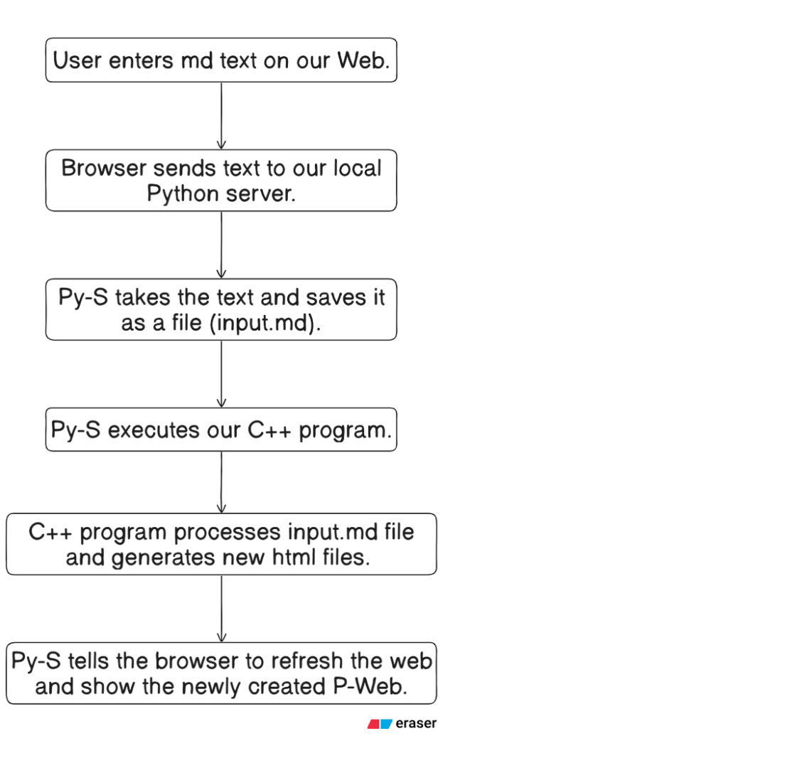
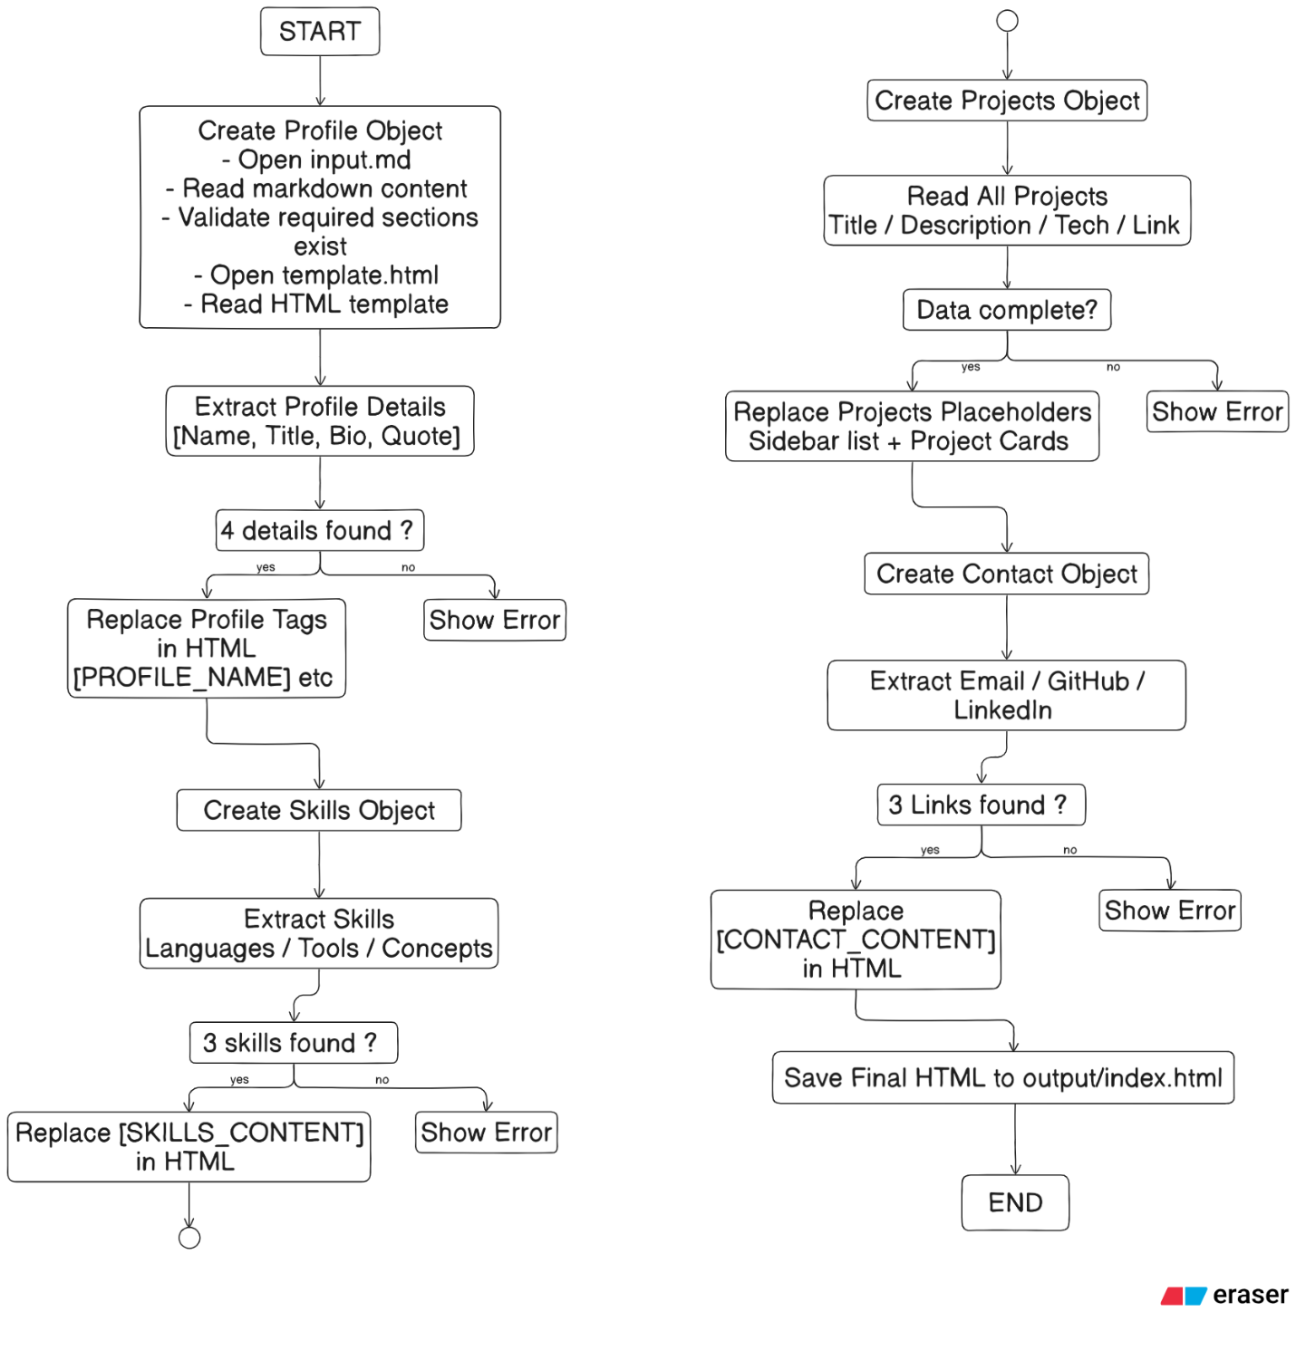

Contributors
Batool Zafar
- Frontend Development: Designed and implemented the user interface for Portify (Completely built by AI).
- Backend Logic: Developed the complete Object-Oriented Programming (OOP) structure.
- Project Management: Managed all documentation, header file integration, and authored the project readme.md.
Muhammad Hashim
- Web Development: Developed the frontend for P-web (Completely built by AI).
- System Integration: Built and configured Server.py. (Completely by AI)
- Quality Assurance: Implemented comprehensive error handling within the OOP framework.
- Documentation: Authored the final Project Report.

Conclusion
Portify successfully demonstrates a powerful integration of low-level C++ logic and modern web technologies. By utilizing OOP principles and a Python-based bridge, the project overcomes browser security limitations to offer an efficient, automated portfolio generation tool. It provides a seamless, professional solution for developers to maintain an impactful online presence.

Screenshots

